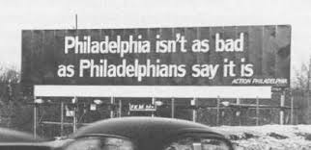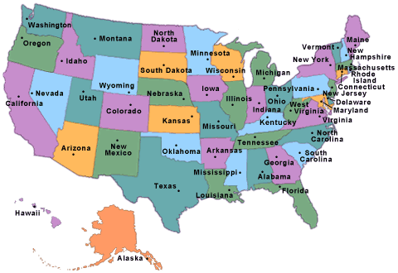

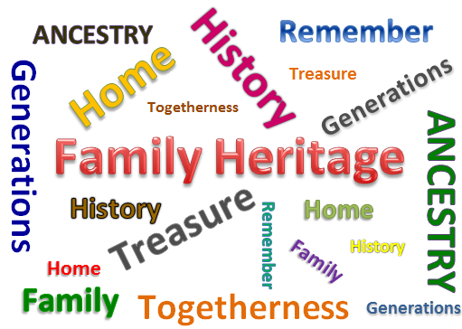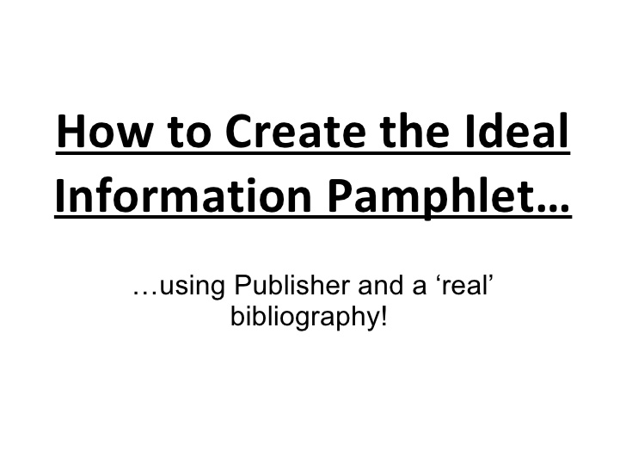

Prediction-

Driving Question: How can we, as Philadelphians, encourage the world to embrace Philadelphia as the first World Heritage City in the United States?

Final Product: Students will create a Pamphlet defining their own heritage and promoting Philadelphia to become the first World Heritage City in the United States.
Vocabulary and concepts that we need to know now… | The question is asking us to… |  | We Know… |  | Questions we will investigate to learn….
I think the answer to the question is…. |  | Mr. Aponte’s 5 Rules |  | Draw the hand signals and what they mean

Civil War and Reconstruction Video Questions
Directions: As you watch the video answer the questions as you hear them being talked about in the video. We will then go over the questions as a class. This is your daily activities points for the class.
- What did the Emanciption Proclamation do ?

- Who wrote the Emancipation Proclamation?

- When did the Civil War end?

- Who was Americas first terrorist group ?

- Why do you think the South reacted so violently to the newly freed slaves?

- Who killed Abraham Lincoln ?

- How many southern men died during the Civil War?

- What did the North do to make sure the southerners did not mistreat African Americans ?

- How much, in present day money, did the slave trade make?

- Who did the radical republicans support African Americans, or the south ? What was their agenda(cause they fought for)? Why were they in danger?

- What did the Freeman bureau do for newly freed slaves?

- Who was president after Lincoln?

- Do you think the president after Lincoln supported equality for newly freed slaves ? Why or why not ?

- What are the black codes ?

Constructed response- Imagine you are a newly freed slave in the south, how would you feel about the freedom you were promised from the Emancipation Proclamation? Do you feel you are on the same level as White Americans? What are you going to do now that you are free to support your family

Historians are detectives who look for evidence, scholars who make a case based on the evidence, and chefs who present the information. In history class, we sometimes read textbooks for information. How are textbooks written? Historians work together, using their expertise, to write textbook entries. What types of sources would historians use while writing a textbook? (\Compare and Contrast)

